Global population from 1960 to 2016

Process Book

Contents
- Introduction
  - Motivation
  - Data
  - Task
  - User
  - Related Work
- Process
  - Data Processing
  - Design Evolution
- Implement
  - Overview
  - Selection Bar
  - World Map
  - Year Chart
  - Parallel Coordinates
- Conclusion

Yanyan Zhang
e-mail: u1127804@utah.edu
UID: u1127804

Lin Yan
e-mail: lin.yan@utah.edu
UID: u1140293

The project repository is here.

1 Introduction

1.1 Motivation:

World population has changed over years in many respects such as "Age dependency ratio (% of working-age population)", "Age dependency ratio, young", "Fertility rate, total (births per woman)", "Life expectancy at birth, female (years)" and "Female population 00-04". Users may need to study these changes to predict future population so that they can plan ahead to provide good education, health care and other services in the future. Different aspects of the world population data are closely correlated to different types of services. For example, studying "Fertility rate, total (births per woman)" and "Life expectancy at birth, female (years)" may tell users how much health services for childbearing will be needed in future years.

There were also interesting changes in values of some attributes throughout years. For example, in the US "Age dependency ratio, young" changed from ~51% in 1960 to <29% in 2016, and "Fertility rate, total (births per woman)" dropped from ~3.6 to ~1.8. In China "Life expectancy at birth, female (years)" increased from ~45 in 1960 to ~78 in 2016. We are interested in visualizing all these changes across countries and years. We also would like to find out explanations (e.g. from economical and political points of view) for these changes if possible. Studying the potential explanation that causes these trends could help users predict the global population in the future and make plans that could meet the current or future needs of people according to different distribution of population.

1.2 Data:

Downloaded from a Kaggle link.
This database presents population and other demographic estimates and projections from 1960 to 2050. They are disaggregated by age-group and gender and cover approximately 200 economies. We can extract all the information we are interested in from this data set, such as “Population Growth( annual %)”, “Population, Female(% of total)”, “Population Total”, “Work-age Population”, “Birth Rate”, “Death Rate”, “Fertility Rate”, and “Life Expectancy”. All of them were stored in one csv file, in the size of 44.2 MB.

1.3 Task:

The primary questions we are trying to answer:
- How do values of certain attributes of global population change over the years?
- How do we compare changes of certain attributes over the years among selected countries?
- How to visualize the population data of all or selected countries in a fixed year?
- How to visualize the population data of a certain country in all or selected years between 1960 and 2016? Are there any correlations among attributes that can be observed from our visualization charts?
What we would like to learn and accomplish:
- Give users a global view of population change. Provide users tools to track attributes they may be interested in from a global point of view.
- If we can find similarities in the change trends of population among certain countries, users could try to figure out explanations that may lead to these similarities.
- Users may be interested in certain attributes of certain countries that are correlated to the demand of certain services. Studying the changes in these attributes over the years will provide quantitative information that may help them determine their future plan.
- If we could match economical or political changes of countries with their population changes in certain years, our visualization could help us explain how economical or political changes could affect global or specific regional population.

1.4 Users:

The target audience could be the general public, the ones who are interested in global population change and specific information. It also could be city planners who would like to rearrange resource based on population in their plan regions. Researchers and educationist in related field may get inspirations from this visualization as well.

1.5 Related Work:

Both members in our group come from China, one of the countries with the largest population in the world. Population is always a hot topic in our country. We believe that developing simple demographic profiles to understand past and current trends of global population is a realistic and interesting topic. Moreover, during the visualization class, we have been exposed to many interesting views and methods for visualizing data, such as table, map, parallel coordinates. By choosing this data set, we can implement some visualization methods we are interested in.

2 Process

2.1 Data Processing

There are several problems we want to solve during data processing.
Firstly, there might be missing data. We tried to interpolate data to fill up small holes in data (during drawing world map) or drop a small amount of lines in which there are too many missing attribute values (during data analysis).
Secondly, the data set is relatively large compared to datasets we used in our previous homework assignments. In order to improve the speed of visualization, we have tried to pre-process the data using Python. Whether it is necessary to use Python for data processing is not decided yet.
Thirdly, we should decide what attributes we want to visualize. Although there are many attributes we are interested in, we cannot visualize all of them due to the limit of time and space. For now, we selected “Population Total”, “Birth Rate”, “Death Rate” and “Life expectancy” for the world map.
Finally, we shall convert the data to the desired format that can be easily used across the charts.

2.2 Design Evolution

All attributes we are interested in are options in a selection bar. For different attributes, we show data in a world map with each country colored accordingly. A color bar is displayed beside the world map. There is also a year chart in which users can select a specific year, and a year slide bar with which users can see transition throughout years.
Users can select one country by clicking it on the map. A line chart of year vs. the selected attribute for the selected country will show up next to the world map. Clicking another country will add another line to the line chart, and so on. This line chart shows comparison among selected countries. If users would like to show comparison in another attribute among the same countries, they can keep the selections of countries and select another attribute in the selection bar. By hovering over a line, a tooltip of more details will pop up. Lines of different countries have different colors. Users can remove the line charts they are not interested in any longer by simply clicking the Remove buttons beside those line charts.
To show multiple attributes in one graph, we use parallel coordinates. For a selected year (or a selected country), we plot countries (or years) and attributes as parallel coordinates. By this chart, we can observe correlation between attributes. Each coordinate can be sorted and be moved to be reordered. Use brush to select part of a coordinate and to highlight paths that go through the selected part of the coordinate.
We can also use table to show data for a selected year. The columns of the table are countries and attributes. The table can be sorted by each column. Countries from each continental can collapse to one group.

3 Implementation

3.1 Overview

Up to now, we have finished part of functions of selection bar, world map, year chart, and parallel coordinates. See here for our project. Following are our hand-written design and images of the part we have done.
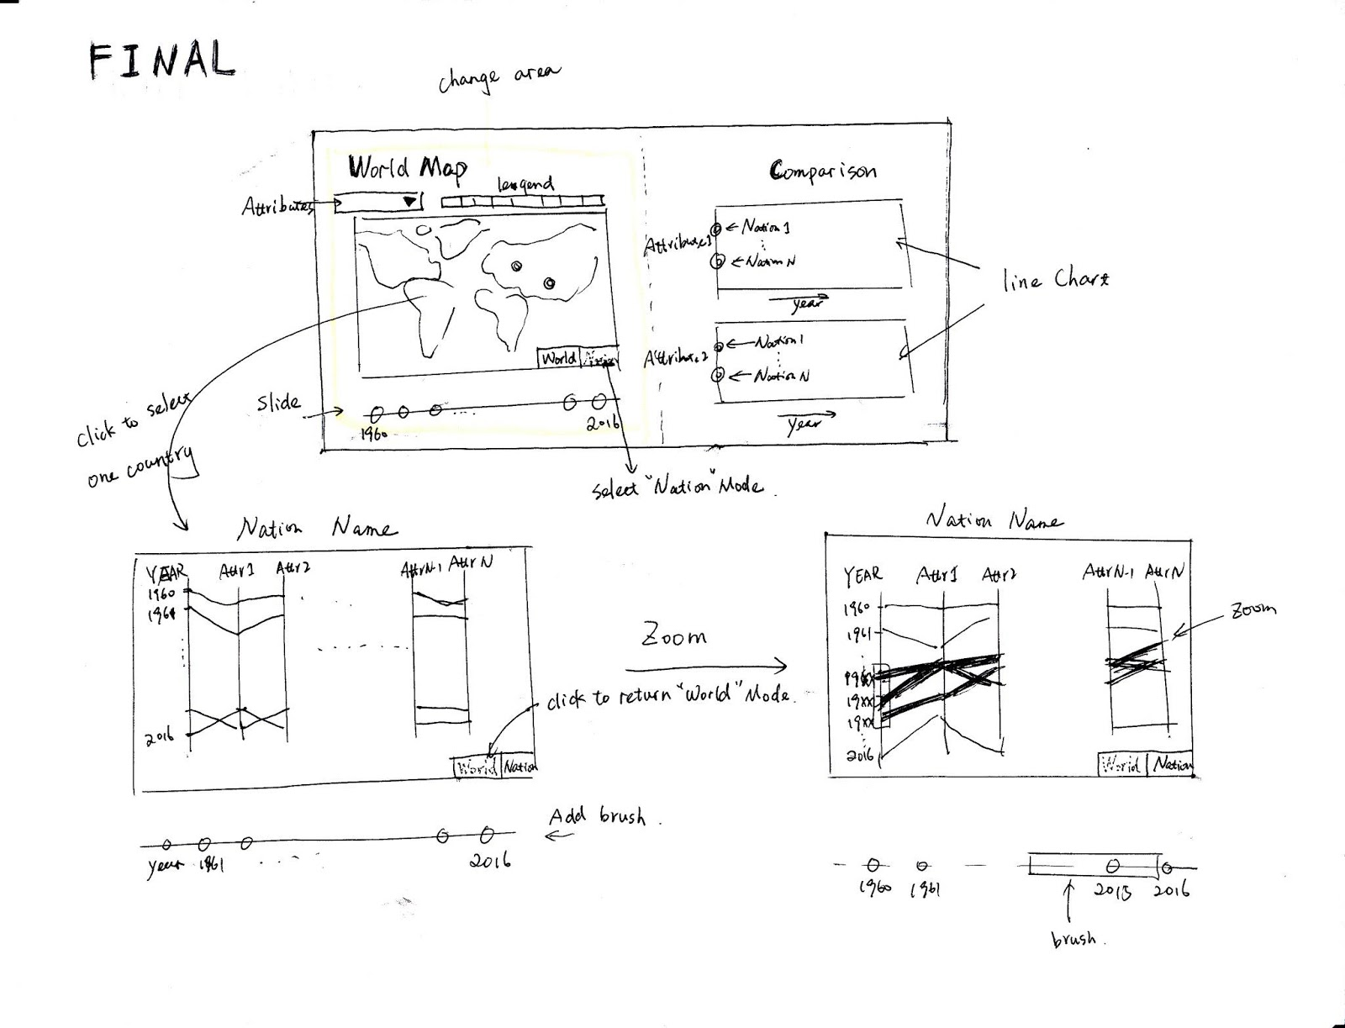
Hand-written Design

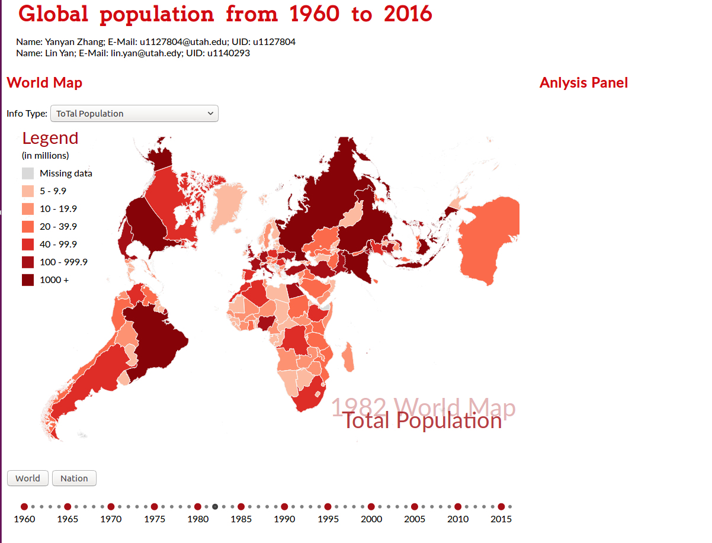
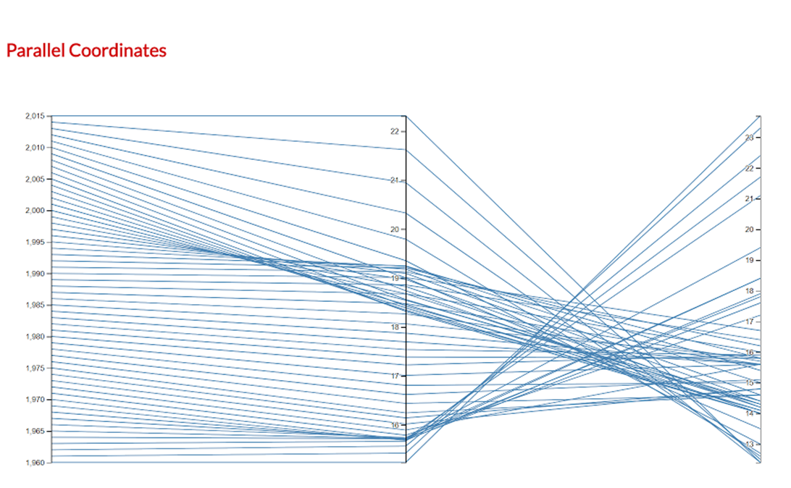
Overview of up-to-now Implementation

3.2 Selection bar

In the selection bar, there are 4 attributes from which one attribute can be picked. The values of the attribute in a specific year can be visualized in the world map.
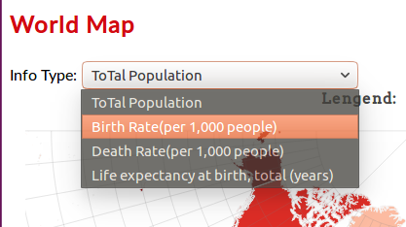

3.3 World Map

The world map can be updated according to the year and the attribute selected by users. It uses different color scales to represent different attributes.
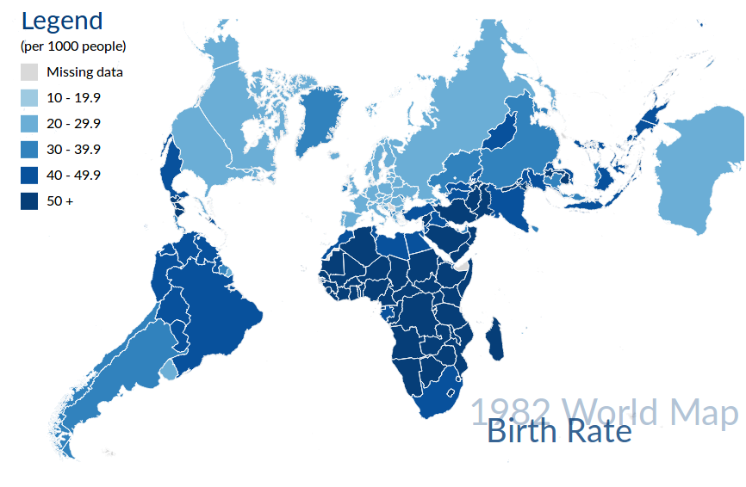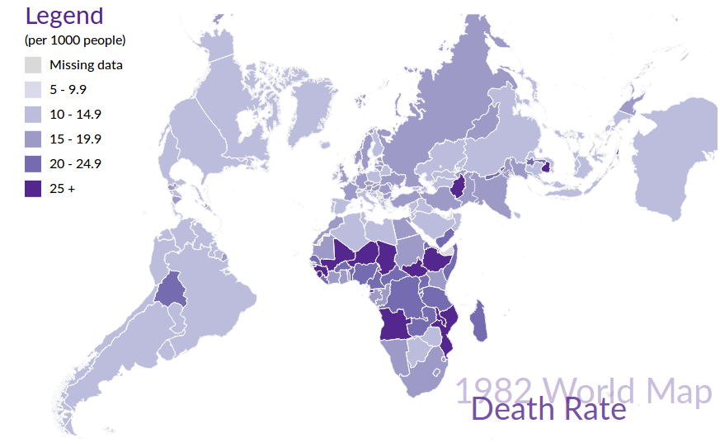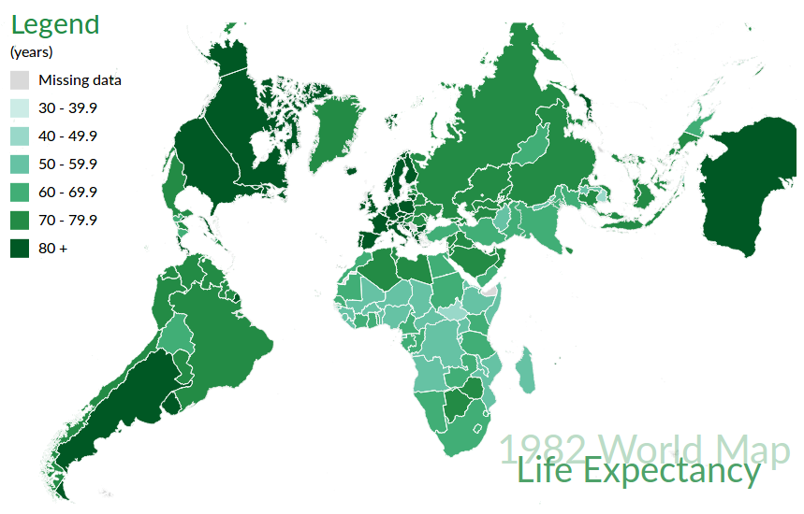

The World Map Updated Based on Different Attributes

3.4 Year Chart:

The year chart displays every five years users can select. When user’s mouse hovers over the smaller circle, the year will display on the top of this circle, and will disappear when user moves the mouse away.

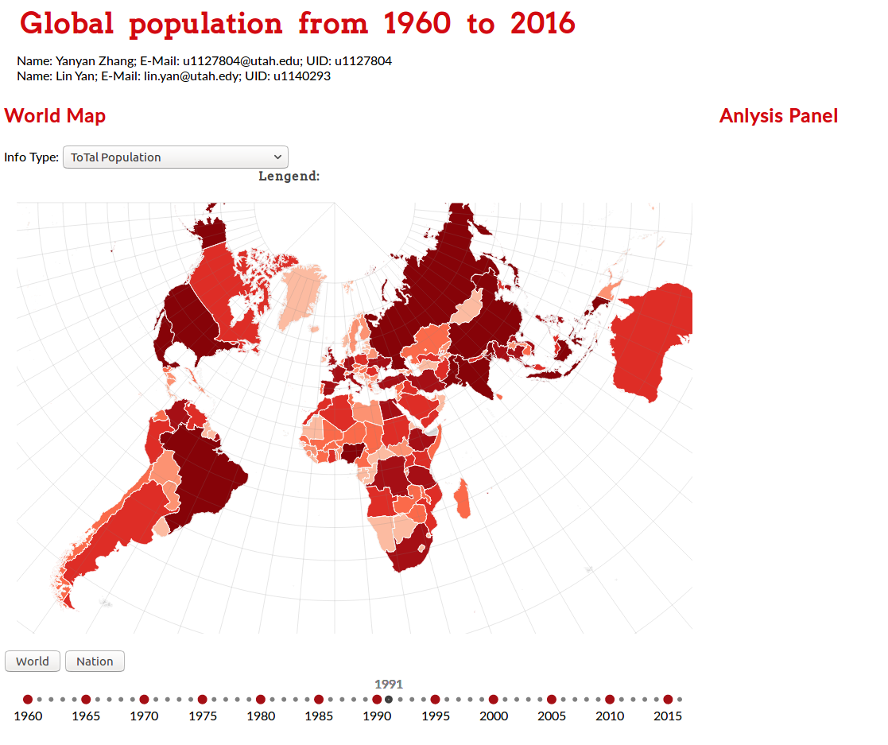

3.5 Parallel Coordinates

A test dataset extracted from the original dataset was used for the parallel coordinates for now. This test dataset contains the values of two attributes of the USA from 1960 to 2015. There are three axes in the chart: ‘year’, ‘Age dependency ratio, old’, ‘Birth rate, crude (per 1,000 people)’. Users can use brush to select a range of values on each axis. The paths going through all the brushed areas are highlighted.

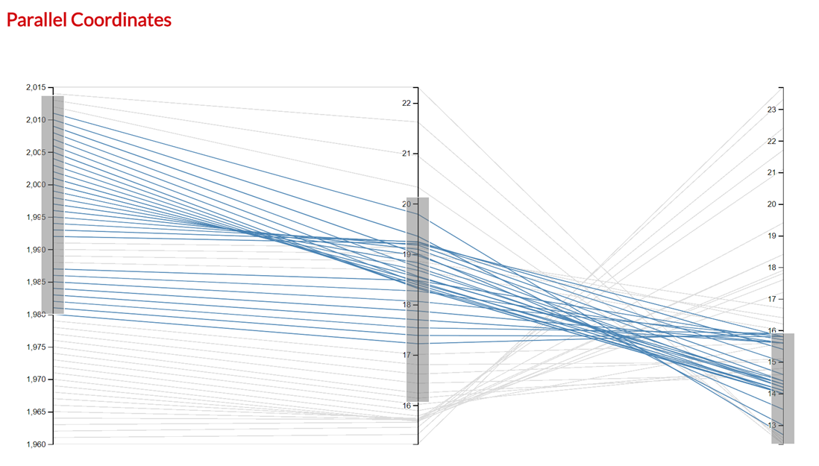

4 Conclusion

Up to now, we have finished several tasks related to this visualization:
- (World map) Give users a global view of population change.
- (Parallel coordinates) Users may be interested in certain attributes of certain countries that are correlated to the demand of certain services. Studying the changes in these attributes over the years will provide quantitative information that may help them determine their future plans.

What should we further improve:
- We can show more information via the world map. We will add tool-tip and zoom on it.
- The year chart is hard to select on. We could add the left/right keys/buttons for small changes of the year selection.
- We could use another world map projection so that a country’s size is proportional to its value of the attribute so that its value can be visible on the map even if the country is very small.
- In the parallel coordinates chart, axes names will be added. And axes can be reordered.

